THE UNITED REPUBLIC OF TANZANIA
MINISTRY OF AGRICULTURE FOOD SECURITY AND COOPERATIVES
DISTRICT AGRICULTURAL SECTOR INVESTMENT PROJECT

SEMI ANNUAL REPORT
FOR YEAR 2011-2012

DASIP/PCU/PR No.2/2011-12 January, 2012

PROJECT BASIC INFORMATION

Project Title: | District Agricultural Sector Investment Project (DASIP)
ADF Loan Number: | 2100150008694
ADF Grant Number: | 2100155003517
Project Cost: | - Foreign Exchange: UA 25.32 Million  - Local Cost: UA 28.82 Million  Total: UA 54.14 Million
Source of Financing: | - ADF Loan: UA 36.00 Million  - ADF Grant: UA 7.00 Million  - GOT: UA 6.85 Million  - Beneficiaries: UA 4.29 Million  Total: UA 54.14 Million
Borrower: | The United Republic of Tanzania (URT)
Executing Agency: | Ministry of Agriculture Food Security and Cooperatives (MAFC)
Date of Project Appraisal | August 2004
Date of Project Negotiation | October 2004
Date of Project Approval | December 2004
Date of Signing Loan Contract | February 2005
Date Loan Declared Effectiveness | December 2005
Date of First Disbursement | November 2005
Date of Last Disbursement | June 2012
Project area: | Twenty eight (28) districts in Kagera, Kigoma, Mara, Mwanza and Shinyanga Regions of Tanzania
Project Components: | - Farmer Capacity Building  - Community Planning and Investment in Agriculture  - Support to Rural Financial Services and Marketing  - Project Coordination and Management
Project Executing Period: | Six (6) years - up to June 2012
Loan Closing Date: | June 2012
Project Launching Date: | 17th January 2006
Currency equivalency: | UA 1 = US D 1.4578

MAP OF TANZANIA SHOWING AREA COVERED BY DASIP
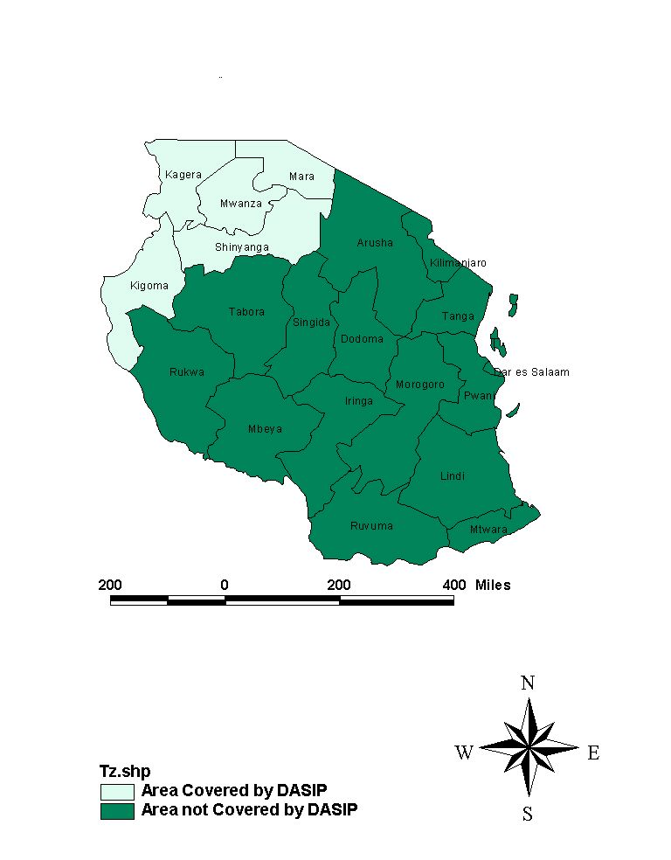

list of abbreviations and acronyms

AfDB | African Development Bank
ASDP | Agricultural Sector Development Programme
ASLMs | Agriculture Sector Lead Ministries
AWPB | Annual Work Plan And Budget
DADP | District Agricultural Development Plan
DALDO | District Agricultural and Livestock Development Officer
DASIP | District Agricultural Sector Investment Project
DED | District Executive Director
DAEO | District Agricultural Extension Officer
DEMO | District Environmental Management Officer
DMEO | District Monitoring and Evaluation Officer
DPO | District Project Officer
DTC | District Training Coordinator
EIA | Environmental Impact Assessment
FAAB | Farming As A Business
FFS | Farmer Field School
GoT | Government of Tanzania
MAFC | Ministry of Agriculture Food Security and Co-operatives
MIS | Management Information System
MTB | Ministerial Tender Board
MTR | Mid-Term Review
PC | Project Coordinator
PFG | Participatory Farmer Group
PCU | Project Co-ordination Unit
PIM | Project Implementation Manual
PTC | Project Technical Committee
RPO | Regional Project Officer
SACAs | Savings and Credit Associations
SACCOS | Saving and Credit Cooperative Society
TNA | Training Needs Assessment
ToR | Terms of Reference
UA | Unit of Account
USD | United States Dollar
VADP | Village Agricultural Development Plan

SEMI ANNUAL REPORT FOR YEAR 2011/2012

BACKGROUND

The Government of Tanzania (GoT), through a loan and grant from the African Development Bank (AfDB) is implementing the District Agricultural Sector Investment Project (DASIP). The project aims at increasing productivity and incomes of rural households in the project area within the overall framework of the Agricultural Sector Development Strategy (ASDS).

DASIP is a six year Project whose implementation started in January, 2006. It covers a total of 28 districts in Kagera, Kigoma, Mara, Mwanza and Shinyanga regions. All project interventions are focusing on achieving the Project outputs which in turn are expected to lead into achievement of the Project objective. Table 1 below indicates names and number of districts covered by the project in each Region.
Table 1: Names and number of Regions and Districts covered by DASIP

Regions | Districts | Number of Districts
Kagera | Biharamulo, Bukoba, Karagwe, Muleba, Ngara, Chato and Misenyi | 7
Kigoma | Kasulu, Kibondo and Kigoma | 3
Mara | Bunda, Musoma, Tarime, Rorya and Serengeti | 5
Mwanza | Geita, Kwimba, Magu, Misungwi, Sengerema and Ukerewe | 6
Shinyanga | Bariadi, Bukombe, Kahama, Kishapu, Maswa, Meatu and Shinyanga | 7
Total |  | 28

Project Components

The Project has three field components and one project management component as follows;

Component 1: Farmer Capacity Building

This component aims at building capacity of 28 districts to train Participatory Farmer Groups (PFGs) through participatory adult education methods. It is anticipated that during the project life, 11,000 participatory farmer groups will be formed. Each group is expected to have, on average, 25 members. Consequently, 245,000 farmers are expected to be trained before the end of the project in year 2012. PFG members are trained in various aspects of their enterprises including; technical, organizational and management skills.

Component 2: Community Planning and Investment in Agriculture

This component aims at building capacity of 28 districts to plan, manage and monitor village and district agricultural development plans. The Project supports 28 districts and 780 villages to prepare and implement District Agricultural Development Plans (DADPs) and Village Agricultural Development Plans (VADPs) respectively. DASIP under this component supports establishment of more than 2,000 agriculture-related investments such as; construction of cattle dip tanks, agricultural technologies; storage facilities, market places, market access infrastructure, water harvesting structures for livestock and irrigation of crops.

Component 3: Support to Rural Micro-finance and Marketing

This component aims at strengthening about 84 Savings and Credit Co-operative Societies (SACCOS) in 28 districts supported by the Project. It is anticipated that, by the end of the project, 90 percent of target SACCOS will be able to maintain a repayment rate of 95 percent and more than 60 percent of SACCOS will be linked with agro processing facilities and marketing associations. Under this component, the project is also expected to establish a well functioning marketing system that will serve farmers in the districts.

Component 4: Project Co-ordination

This component deals with day-to-day co-ordination and management of project activities. The Project Coordinating Unit (PCU) which is based in Mwanza is responsible for coordinating Project activities and ensuring all project resources are managed prudently.

Project Beneficiaries

Beneficiaries of the project are Participatory Farmer Groups and their grassroots institutions such as Savings and Credit Associations (SACAs) and Savings and Credit Co-operative Societies (SACCOS) and communities in 780 villages where facilities are being constructed or rehabilitated. It is estimated that a total of 3.4 million people in 0.57 million households will benefit directly or indirectly by the end of the project. At least 23% of the beneficiaries are expected to be female-headed households.

PROJECT IMPLEMENTATION

This report presents the status of project implementation during the first half of the financial year 2011/2012. The report presents progress of implementation of activities as per Annual Work Plan and Budget (AWPB) for the year 2011/2012 and provides analysis in qualitative and quantitative terms the progress of planned activities. The report also provides results that emanate from project interventions and highlights challenges encountered during the implementation process. This report concludes by outlining mechanism for coping with existing challenges including planned activities for the next quarter, January to March 2011/2012

Planned Activities by Component for the year 2011/2012

Component 1: Farmer Capacity Building

- Training of DTC and conducting Districts planning workshops,
- Conducting Regional Programme Development Workshops,
- Supporting District Trainings by Ward Level Training Facilitators,
- Supporting HIV/AIDS Sensitization Campaigns,
- Farmer to Farmer visits and Preparation for Farmers exhibition “Nane nane” shows, and
- Supporting investments in Mini projects as a training exercise.

Component 2: Community planning and investment in agriculture

Facilitating O&OD training and village planning process,

Support Districts on M & E activities including Procurement and accounting functions,

Supporting District Project Officers to supervise Project Activities,

Supporting Irrigation activities in the Project area and District Project Officers to effectively supervise Project Activities,

Conducting training on Environmental Impact Assessment and Environmental and Social Management Training,

Support Ward officials on EIA and ESMP issues and training of village Development Committees,

Supporting implementation of Village micro-projects, and

Support activities related to investments in Medium Size Rural Infrastructure, Agricultural Technologies, Strategic Market Centers and Village Micro projects.

Component 3: Support to Rural Micro-Finance Services and Marketing

- Strengthening of rural savings and credit institutions,
- Development of marketing systems,
- Conduct various training related to rural Micro Finance and Marketing,

Component 4: Project Coordination

Procurement of Goods and services,

Preparation of Withdrawal Applications,

Disbursement of Project Funds to district, maintain Accounts, and consolidate Project Accounts,

Preparation and arrangements for carrying out Annual Audits,

Preparations for PTC Meetings,

Monitoring and evaluation of Project activities,

Conduct follow up initial training and undertaking National Planning and Review Workshops,

Conduct training on procurement and financial management issues,

Production of communication materials,

Assessment of village investments, and

Conduct Topical studies.

Implementation of planned activities

According to the Annual Work Plan and Budget for year 2010/2011, the Project planned to execute 28 activities. Up to 31st December 2010, 19 out of 28 planned activities were implemented, an achievement 68 percent. Progress of implementation of planned activities during the first half of year 2011/2012 focused on consolidation, strengthening and streamlining sustainability of project interventions. Detailed implementation component wise is as explained here under;

Component 1: Farmer Capacity Building

In view of the above, the following activities have been implemented.

- Supervision and follow up activities for PFGs

From July to December, 2011, the project directed its efforts towards institutional and technical capacity building of 11,150 PFGs formed since project inception. These PFGs so far have 247,211 farmers. Available data indicate that 116,191 of farmers (equivalent to 47%) are women and 131,020 are men. The women to men ratio are closer to the target of 50% envisaged at Project Appraisal.

Institutional capacity building interventions focused on training PFGs on preparation and use of business plans, proper record keeping, production of quality project reports, group leadership and management, tracking of PFG adoption and formation of PFG associations.

A major thrust for this financial year is on consolidation of interventions implemented since project inception. This approach is necessary because most of the activities for this component have been implemented. Accordingly, more than 90% of resources under the Farmers Capacity Building Component have been utilized. Through routine monitoring of project activities, it has been observed that there are significant gaps that need to be bridged before the end of the project life. Some of the gaps identified through field visits and district reports indicate that;

- There are many PFG members who were trained since project inception who have not adopted improved agronomic practices;
- Mentoring of PFGs in organizational and managerial aspects is still a necessity because many PFGs are still weak in this area;
- Extension service delivery system is still weak.
- Many PFGs and PFG members have not adequately mastered skills that will enable them to transform their activities into commercial entities;
- Most PFGs have not constituted themselves into Associations. Associations are expected to enhance farmers’ bargaining power especially during marketing of their produce.

Despite the observed gaps, many PFGs were successful in increasing crop productivity and incomes and preparation and use of business. This was a result of regular training and follow up by Ward Training Facilitators and DTCs. It is envisaged that, if these efforts are sustained till the end of the Project, most farmers will be able to keep records for their farm activities which in turn will enable them to take informed decisions in resource allocation at household level.

Available information shows that, the Farmer Field School approach has enabled many farmers to keep track of their activities and determine profitability of their enterprises. For instance, Mr Nasib Mulokozi from Umoja PFG at Buhigwe/Mulera village in Kasulu district has been able to keep his banana farm records. After graduating from the FFS in 2008/09, he and his wife adopted improved banana farming and planted 50 banana suckers in their plot. With guidance from their Ward Agricultural Extension Officer (WAEO) and Farmer Facilitator (FF), this farmer and his family expanded the size of their banana plot. Mr Nasib is now able to project his family income. For example, he is expecting to earn about TZS 2 million from selling banana bunches and suckers between January and December 2011.

Regarding technical capacity building, the focus was mainly on training PFGs on adoption of improved farming practices both in crop and livestock production. Ward Agricultural Extension Officers and Farmer Facilitators with backstopping from District Training Coordinators provided regular training to 11,150 PFGs in the project area. Available data reveals that regular training has resulted in a significant increase in maize, paddy and cotton productivity among farmers who adopted all improved farming practices. Most farmers who have been interviewed, indicate that training is a major factor behind observed changes in crop productivity as indicated hereunder;
Maize productivity

Maize productivity among farmers who adopted all improved farming practices has increased more than four times to an average of 4.2 tons per hectare. As a result, these farmers have been able to produce maize to meet their household food requirements and surplus for sale. Households are now food secure contrary to the situation before the project.

A maize plot established by Azimio PFG

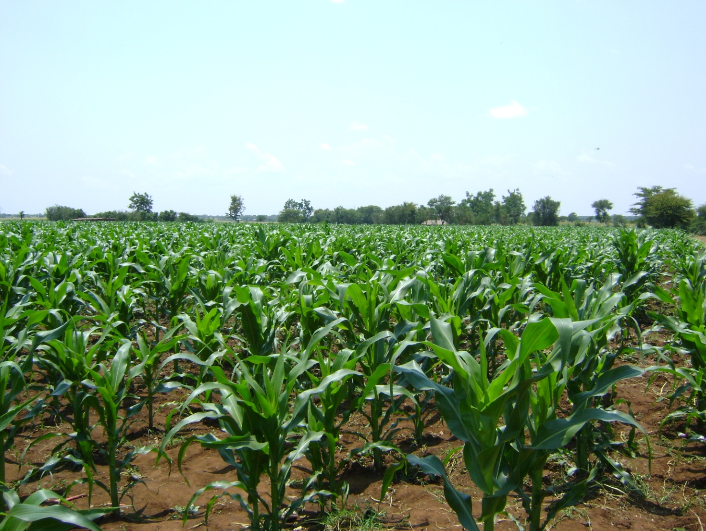

Figure 1. This is a maize plot used by Azimio PFG members in Mwashata village in Meatu district to learn how Farmer Field School (FFS) can be a learning ground for improving maize productivity. There are several similar plots established by PFGs in Meatu district.

Productivity of paddy

Data from districts reveals that productivity of paddy for PFG members who adopted all improved farming practices increased more than two and half times in comparison with the “before and after project” scenario. Paddy yields improved from an average of 0.99 tonnes to 3.2 tons per hectare among districts producing paddy in the project area. Improvement in paddy yield in these districts resulted from adoption of proper spacing, water management and improved seed bed preparation.

Cotton productivity

Information derived from the field revealed that the majority of PFG members who observed all improved cotton farming techniques recorded increased cotton productivity more than two times in major cotton producing areas. For example, in some districts, cotton productivity increased from 0.5 to 2 tons per hectare while in other major cotton growing districts the increase was from 0.9 to 3 tons per hectare as compared to the baseline data which range from 0.54 tonnes per hectre to 1.23 tonnes per hectare. (DASIP Baseline Study Report 2008).

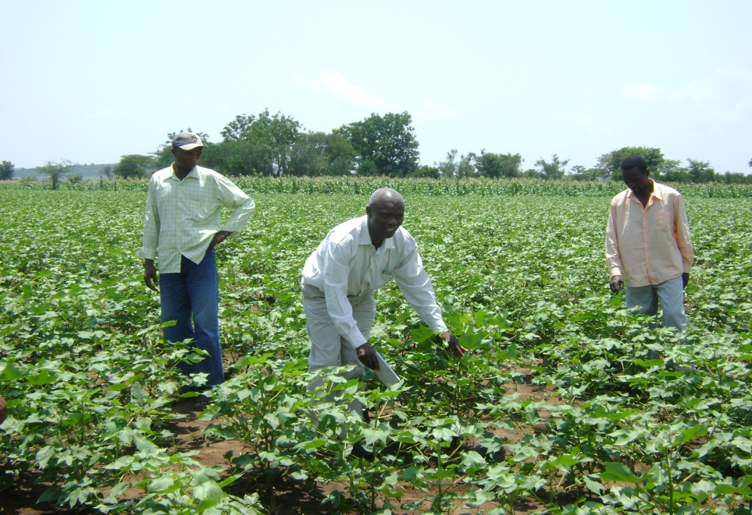
Figure 2. The district Training Coordinator in Meatu district, Mr. Mwijarubi Nyasebwa, advising Mkombozi PFG member in Mwashata village on improved cotton production. The farmer adopted this innovation after attending Farmer Field School (FFS) training through DASIP support.
Two diagnostic studies will be carried out in the third quarter of year 2011/12 in the higher rainfall agro-ecological zone (the banana-coffee cropping system) and in the lower rainfall agro-ecological zone (cereal-cotton cropping systems). The study will gauge the impact of the project interventions and compliment existing data.

Power tillers

In order to boost crop production, the project procured and distributed 300 power tillers to 300 farmer groups in year 2010/11. The power tillers are intended to enable farmers in the project area expand their plots. Farm operations, currently done by power tillers include; tilling, puddling, leveling and transporting farm produces from villages to markets. Some PFGs have started to use their power tillers to perform other operations such as hulling (in Tarime district) and water pumping in Magu and Ngara districts.

For technical, financial and institutional sustainability of these power tillers, some measures have been put in place. For instance, for technical sustainability, the project supported a two week training for 35 Agro mechanization officers from 27 district councils at KATC, Moshi in year 2010/11. After completing their course, the officers trained all power tiller operators on operation and maintenance of the power tillers in their respective districts. District mechanization technicians are now providing technical backstopping which have enabled PFGs to manage their power tillers properly.

Follow-up trainings to 19 Agro mechanization officers and 96 power tiller operators were provided by suppliers of power tillers (Farm Equip Tanzania Limited and Noble Motors) during this financial year. During the training, suppliers provided technical advice and fast wearing spares critical to operation of power tillers.

The project has registered a number of benefits as a result of using power tillers. Among the benefits are as follows;
- Power tillers are more efficient than oxens and use of hand hoes in cultivation. Field reports show that trained power operators are tilling up to one hectare per day depending on operator’s skill, soil characteristics and land topography. There are indications that, during the upcoming long rain farming season (January – May), power tillers will substantially increase the area under crop cultivation. One power tiller is expected to cultivate between 50 and 60 hectares. Districts have been advised to tract performance of every power tiller in their district. This exercise is expected to lead into determination of total area cultivated during the season.
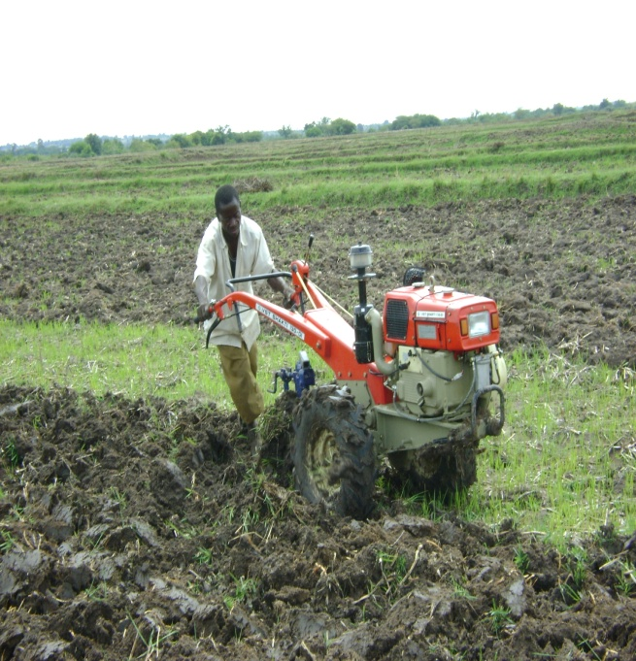 | 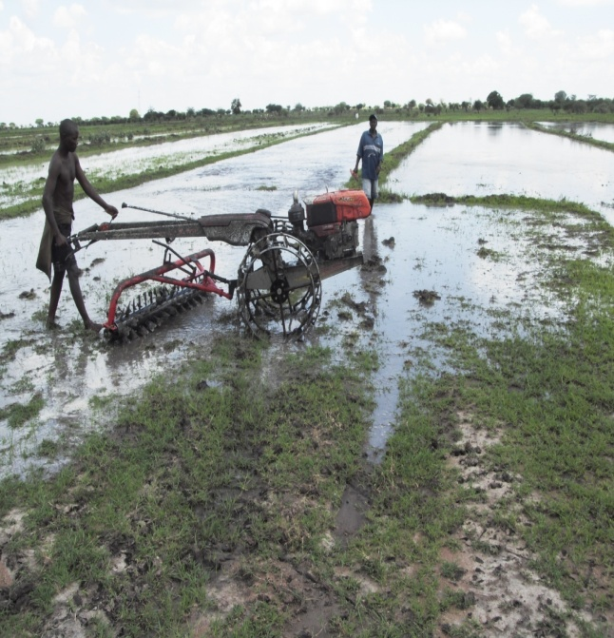
Figure 3. Trained power tiller operators in Kwimba and Shinyanga Rural district show how to use power tillers in performing different farm operations. In this picture, the operators are tilling (left) and puddling (right) theirs farms.
- Some PFGs are recouping their investments very fast, because some powertillers have already generated over 25% of the buying cost in the first year of operation. Due to multipurpose use of power tillers, a number of groups are using them in water pumping in Magu district and hulling in Tarime.
- Introduction of power tillers has enabled farmers to transport crop produces from production centers to markets where they can earn higher prices.
- The power tillers are gradually replacing the animal power in some districts e.g. in Shinyanga district. Farmers have admitted that power tillers are used immediately after onset of rainfall unlike in oxen where some time are required to feed weak oxen affected by drought. In Tarime district where oxens are being used for cultivation, PFG members testified that theft of oxen has declined.
Sustainability measures

In order to ensure sustainability of the power tillers, the project has put in place measures to sustain farming activities using power tillers through; Supporting training for agro mechanization officers and power tiller operators and advising districts to sensitize potential individuals and companies to act as agents of spare parts for power tillers. Lastly to strengthening capacities of PFGs in managerial and business skills

Despite the fact that some successes have been registered, there also some challenges such as; improper use of power tillers in transporting construction materials and passengers, inadequate agents for power tiller spare parts, inadequate management and business skills, Poor land topography

Inspite of such existing challenges the project has put forward strategies as remedial action for encountered challenges. Action set forward are supporting training for agro mechanization officers and power tiller operators, advising districts to sensitizing potential individuals and companies to act as agents of spare parts for power tillers and strengthening capacities of PFGs in managerial and business skills

Collaboration with other development institutions

Establishment of PFGs in the project area has been a great opportunity to some development stakeholders. This can be substantiated by additional financial and technical supports given to established PFGs in the project area. For instance, TechnoServe adopted DASIP groups in Bunda district in cotton production with emphasis on Farming as Business. Similarly, Mogabiri Farm Extension Centre based in Tarime, Catholic Relief Service and Ukiriguru Research Institute used the project PFGs in Serengeti district for multiplication of disease tolerant cassava cuttings. Serengeti National Park (SENAPA) through Frankfurt Zoological Society supported poultry PFGs bordering with the par and involved in chicken production in Serengeti district. The support were in the form of accessing veterinary drugs and access to markets.

- Supporting PFG mini-projects

Over this reporting period; Biharamulo, Muleba, Magu and Bariadi districts assessed and approved business plans for 461 PFGs. Consequently, PCU disbursed TZS 184.400 million to the respective districts to enable the said PFDGs to establish their income generating activities. Cumulatively, the project has already released TZS 1,437,600,000 to 3,594 (77%) trained during the last training season. The mini-grants contributed positive results both PFGs and PFG members as indicated below.

Impact of mini-grants to PFGS

Mini-grants to the PFGs have started to show positive results including income growth among PFGs and PFG members. These grants have also enabled PFGs to diversify their economic activities into more than one enterprise, expansion of enterprises and stimulated a culture of savings and which has been exhibited by prevalence of informal savings and credit organizations.

For instance, after receiving a mini-grant of TZS 400,000 in 2007/08, Msaligula PFG at Lutale village in Magu district generated TZS 6.6 million from sales of horticultural crops. The group is operating an informal microfinance scheme known as "Ifogongo". The PFG members are now enjoying easily accessible services and soft loans from their Ifogongo. An increase in Msaligula PFG income registered above was attributed to effective Farmer Field School training which resulted into increased crop productivity and thus more revenue to the group. Similarly, mini-grant disbursed to the PFG helped them to expand their enterprise and hence more income which were used in "Ifogongo". Similarly, another PFG known as Umoja wa Wafugaji Kuku formed in 2006/07 at Nyampande village in Sengerema district generated TZS 5.2 million from sales of poultry, pigs and charging interest rates from revolving funds in informal microfinance locally known as "Ifogongo". Success of this group is attributed to adoption of an improved hatching technique known as “Programmed hatching”, diversification of enterprises and operating “Ifogongo” . In programmed hatching, hens are restricted from brooding.

Mini-grant has also contributed into achievements recorded in Umoja Chaki PFG in Sirari Village in Tarime district. A combination of mini-grant received by this PFG in 2009/10, FFS training in 2008/09 and ownership of Kubota power tiller stimulated Umoja Chaki to expand the area under maize production. In this group, maize productivity is linked to timely planting, use of improved hybrid seeds, proper weeding, application of fertilizer, planting by space and pest control. Adoption of these improved farming practices and expansion of the area under crop cultivation contributed into increased maize production and thus PFG’s income. Increased income enabled the group to buy a maize huller and operate an informal micro finance scheme for its members. Field data shows that until November, 2011 Umoja Chaki had generated TZS 4 millions saved at CRDB, TZS 0.4 millions deposited at NMB and TZS 4 million circulating among PFG members through an informal microfinance established by PFG members themselves.

Impact of mini-grants to individual PFG members

At individual level, a combination of FFS and mini-grants disbursed to PFGs enabled PFG members to excel in their economic enterprises. A combination of PFGs training on improved farming practices and skills gained from operating income generating activities has enabled some PFG members to establish successful income generating activities. Thus enterprises established through income generating activities have provided training ground for PFG members and there is every indication that the project objective of enhancing farmers’ incomes will be attained at the end of project life.

For example, the mini-grant disbursed to Mkombozi PFG in 2007/08 at Miseke village in Serengeti district enabled the PFG to establish disease tolerant cassava cuttings enterprise. From the group’s enterprise, Mrs Agness Joshua and the rest of the members in Mkombozi PFG learnt how to multiply the cuttings and later adopted this innovation on her farm. After adoption, Agnes established 0.5 acre (0.2 Ha) and later expanded it to 5 acres (2 Ha). This plot is among the major source of disease tolerant cassava cuttings both in the district and region. Demand for these cuttings have not only contributed into Agnes’ household income but has also improved household food security among farmers within and outside the district. A number of farmers in Miseke and neighboring villages have adopted improved cassava farming from Mkombozi PFG and Agnes’ plot. The adoption has resulted into increased cassava productivity and production in the area.

Similar results were recorded for Mr. Godfrey Christopher of Tweyambe PFG formed in 2006/07 and obtained mini-grant in 2007/08 in Muleba district. Mini-grant enabled the group to buy one improved buck (male goat) and one doe (female goat) for improvement of indigenous goat breeds. Mr Christopher and his colleagues in the group used that pair of improved goat as a learning ground and later adopted the innovation. The improved buck bought using mini-grant from the project driven Mr Christopher to cross breed the PFAG’s improved buck with his indigenous does. From two indigenous does he owned, Mr Christopher multiplied his flock to 12 improved goats which were later sold and enabled him to buy an improved dairy cow. Like Mr Christopher, other 6 members in the group also own improved goats and the remaining 6 members in the group have conceived goats. Similar examples are common in the project area.

- Formation of PFGs associations

The project disbursed TZS 18.550 million to support formation of PFGs associations in 140 project villages in 7 districts namely; Ngara, Kasulu, Maswa, Bariadi, Tarime, Geita and Sengerema.

After realizing benefits of PFGs associations, supported districts through Farmer Facilitators, Ward Agricultural Extension Officers and District Training Coordinators mobilized and united 2,500 PFGs who voluntarily formed 190 PFG associations. As a result, other districts are facilitating formation of Associations in their areas of jurisdiction.

Reports from districts indicate that establishment of these simplified the work of assisting PFGs to from SACAs which will later be transformed into SACCOS. PFG Associations have also been beneficial in terms of delivery of extension services to PFG members, resolving conflicts, market networking, exchange of information and monitoring and evaluating PFGs progress.

- Nane-nane agricultural shows

During this reporting period, the project disbursed TZS 39.150 million to 13 project districts for ‘Nane-nane’ shows. A total of 218 participants (90 district officials, 58 Ward Agricultural Extension Officers and 70 farmers) from districts participated in the shows. Various crop produces, livestock products and agricultural technologies were displayed. District officials and extension officers who participated in the shows supported farmers to explain to participants technical aspects of their displays.

During the show, both farmers and extension officers disseminated knowledge to their fellow farmers and gained knowledge from other stakeholders including researchers, NGOs, extension officers, farmer groups and agricultural input suppliers.

Apart from knowledge gained or disseminated, PFG members sold most of their products at relatively higher prices and also established market connections with traders and institutions. For example, during the show, poultry farmers from Mtazamo PFG in Kijuka PFG in Sengerema district secured a market for local chicken from traders in Mwanza city. Markets connections outside the district were also recorded for PFG members producing pineapples in Ukerewe, banana in Kasulu and rabbit in Misungwi districts. For instance, Mr Simon Ndalahwa from Chankamba village in Ukerewe district secured market for 300 pineapple suckers from Eden Secondary School in Mwanza. Similarly, banana farmers who participated in the show in Kasulu secured markets for banana suckers from other farmers within and outside the district as well as a neighboring country, Burundi. PFGs involved in rabbit production in Misungwi established market connections with some traders in Mwanza.

- Training district staff

During implementation of the project interventions, a number of challenges hindering the project success were encountered. Regarding utilization of completed community infrastructures, it was observed that there were completed community infrastructures which are either being used partially or not being used at all in some project villages. The challenge ahead is to unsure full utilization of community infrastructures. Similarly, despite the training on business plans conducted to all PFGS by Ward Agricultural Extension Officers with back stopping from District Training Coordinators, still there are PFGs without knowledge and skills in this subject. The project would therefore like to see economic enterprises of PFGs operated as business entities. Other challenges were inadequate PFG tracking adoption data from project villages and lack of quality project reports from villages and districts.

In order to enable district staff to address observed challenges, PCU organized and conducted two separate trainings more effectively, that were aimed at building capacity of all District Project Officers (DPOs), District Monitoring and Evaluation Officers (DMEOs), District Training Coordinators (DTCs) and District Agricultural Extension Officers (DAEOs) from 28 project districts to work on the challenges.

The first training for DTCs and DAEOs was conducted between 24th and 27th October, 2011 at Karena Hotel in Shinyanga. Using a guideline on supervision and operation of community infrastructure and agricultural technology developed by PCU in collaboration with district officials, 56 district officials (28 DTCs and 28 DAEOs) were trained on supervision and operation of community infrastructures and agricultural technologies by groups approved by Village Council.

Training of Village Councils using the developed guideline is expected to establish effective and functional groups that will supervise, manage and operate community infrastructures and agricultural technology projects. Furthermore, the guideline is inculcating to community the sense of ownership of constructed infrastructures and also resolves conflicts of interest among stakeholders. For instance, the guideline stipulates clearly distribution of profits accrued from operating infrastructures, ownership of infrastructures and formation of groups that will operate the infrastructures.

Other areas covered during the training were preparation and use of business plans, tracking of PFGs adoption data, formation of PFGs associations, Farmers Field Schools, preparation of quality project reports and value chain analysis. Facilitators in this training came from the Ministry of Agriculture Food Security and Cooperative (MAFC), Sokoine University of Agriculture (SUA), MUCCOBS, Techno Serve, PCU and three project districts namely Serengeti, Sengerema and Ukerewe. This training was followed by another training which comprised of 28 DPOs, 28 DMEOs and 5 Regional Project Coordinators (RPOs) in the same venue between 31st October and 3rd November, 2011. The training contents in both trainings were the same.

The project is expecting that after these training, communities in the project area will operate their infrastructures and agricultural technologies efficiently, effectively and sustainably. Similarly, use of business plans by project groups (groups operating community their infrastructures and agricultural technologies, PFGs) is expected to spread to more project beneficiaries.

Similarly, during this reporting period, technicians from Farm Equip Tanzania Limited conducted training to 19 district agro mechanization staff and 96 power tiller operators from 96 PFGs in 12 project districts namely Tarime, Magu, Bariadi, Misungwi, Kwimba, Kahama and Shinyanga. Other districts are Shinyanga, Maswa, Meatu, Biharamulo, Ngara and Misenyi.

Apart from the training, the technicians provided after sale services to 135 Kubota power tillers that were supplied by Farm Equip Tanzania Limited and distributed by the project to the districts. To ensure sustainability and proper maintenance, districts are identifying potential agents to supply spare parts from Farm Equip Tanzania Limited. Already there are two suppliers of the parts in Shinyanga and Mwanza regions and others are in negations process with the supplier.

- District Planning and Regional Programme Development workshops

District Planning and Regional Programme Development workshops were conducted in Shinyanga between 28th and 29th, October 2011 to review progress of activities implemented under the Farmer Capacity Building component. The workshops comprised of 28 DTCs, 28 DAEOs, 10 PCU staff and 5 farmer representatives from Kasulu, Serengeti, Muleba, Maswa and Sengerema districts.

During the workshop, participants reviewed progress under Farmer Capacity Building and identified challenges under the component. Identified challenges include tracking of PFG adoption data, accuracy of data and reports, preparation and use of business plans by PFGs and proper use of agriculture technologies managed by PFGs.

Based on challenges identified, DTCs and DAEOs prepared Plan of Actions (POA) which address identified challenges. It is anticipated that execution of district plans will provide solutions to the challenges. Some activities in the district plans such as sensitization on formation of PFG associations and tracking PFG adoption have started to be implemented in the villages.

Component 2: Community Planning and Investment in Agriculture

Community Planning

Before fund disbursement, the project undertakes the process of identifications of activities to be funded through the Opportunities and Obstacles to Development (O&OD) processes. Activities identified are incorporated into the Village Agricultural Development Plans (VADPs) and District Agricultural Development Plans (DADPs). DASIP is charged with a task to ensure VADPs and DAPs prepared reflect needs and aspirations of communities.

In order to ensure districts are preparing good DADPs and are capable of providing necessary technical support to villages to prepare their VADPs, DASIP conducts training to DFTs every year. DFTs in turn train WFTs whose responsibility is to facilitate preparation and implementation of VADPs. The training is normally based on gaps identified in the previous year. The current 348 implemented projects during this reporting period is the result of O&OD processes and were incorporated into DADPs for the year 2011/2012. Major areas which were emphasized during the last planning exercise include; environmental and social management techniques, entrepreneurship skills, Monitoring and Evaluation of activities at community and district levels, record keeping and reporting, preparation of business plans and tracking progress of agricultural activities supported by the Project and other financiers. All these significant areas were geared towards effective implementation and sustainability. Project activities which were identified through this process were also incorporated into DASIP AWP&B as implemented here under;

Investment in Agriculture

DASIP supports investment in agriculture through implementation of village micro projects and agricultural technologies. A target of 2,000 micro projects and agricultural technology set for the entire project period is an indicator to measure achievement of the project. Currently, 2,297 (1,439 Micro projects and 858 Agricultural technology) have been supported, which is an achievement of 115 percent of the set target during Mid Term Review. Details related to implementation of micro-projects are as provided hereunder;

Support to village Micro-projects

During the first half of this year, 2011/2012 DASIP supported the districts to implement 348 new projects (i.e. 212 village micro projects and 136 agricultural technology projects) and constructed 105 ancillary structures. The projects worth TZS 3,824,707,250 have been implemented: DASIP contributed TZS 3,059,766,000 while TZS 764,941,500 was community contribution (the list of projects is attached as Annex II).

Since its inception in 2006/07, DASIP has supported implementation of 2,297 micro-projects worth TZS 30,882,814,250 of which DASIP contributed TZS 24,335,687,200 and the balance was contributed by the communities. These projects include 1,439 infrastructure projects and 858 agricultural technology projects in all the 28 districts.

Infrastructure projects include; 212 cattle dips, 97 permanent cattle crushes, 26 slaughter slabs,164 crop storage structures, 146 market sheds, 337 Charco dams, 213 feeder roads (with 579.9 km), 11 milk collection centres and 233 other projects such as soil and water conservation, construction of fish ponds, coffee pulperies, ward resources centers, shallow wells / bore holes and cattle troughs. See Table 2 below.

Table 2: Summary of infrastructure Projects by regions since project inception

 | INFRASTRUCTURE-PROJECTS (Community Projects)
Regions | cattle dips | cattle crushes | slaughter slabs | Charco dams | crop storage | market sheds | No. and length (km) of feeder roads | Milk collect. centres | Assorted | Total
Kagera | 29 | 38 | 5 | 29 | 56 | 29 | 59  (158km) | 1 | 71 | 317
Kigoma | 18 | 4 | 3 | 7 | 11 | 38 | 59  (162km) | 0 | 17 | 157
Mara | 56 | 1 | 4 | 110 | 0 | 10 | 20  (57km) | 10 | 29 | 240
Mwanza | 52 | 54 | 6 | 85 | 28 | 49 | 36  (96.9km) | 0 | 52 | 362
Shinyanga | 57 | 0 | 8 | 106 | 69 | 20 | 39  (106km) | 0 | 64 | 363
Total | 212 | 97 | 26 | 337 | 164 | 146 | 213  (579.9km) | 11 | 233 | 1,439

- Support to rural Agricultural technology;

During the first half of year 2011/2012, the project implemented a total of 136 agricultural technology projects. Since project inception, a total of 858 agricultural technology projects have been supported. These projects include; 301 grain hulling and milling machines, 91 oxen drawn implements, 325 power tillers, 33 cassava chipping machines, 5 milk separators, 28 oil pressing machines, 13 chicken incubators and an assortment of other 62 technologies (e.g. coffee hullers, fruit processing, wine processing and water pumps).Table 3 below shows the distribution of agricultural technologies region wise.

Table 3: Summary of Agricultural technology projects by region

Region | AGRICULTURAL TECHNOLOGY PROJECTS
 | Power tillers | Grain milling machines | Milk separators | Oil pressing machines | Oxen implements | Chick incubators | Cassava graters | Assorted | total
Kagera | 48 | 63 | 0 | 3 | 2 | 0 | 7 | 16 | 139
Kigoma | 29 | 78 | 1 | 11 | 2 | 0 | 6 | 8 | 135
Mara | 39 | 53 | 4 | 4 | 45 | 13 | 17 | 14 | 189
Mwanza | 82 | 56 | 0 | 4 | 28 | 0 | 1 | 19 | 190
Shinyanga | 127 | 38 | 0 | 6 | 14 | 0 | 2 | 18 | 205
Total | 325 | 288 | 5 | 28 | 91 | 13 | 33 | 75 | 858

Results of Cattle dips and Clashes
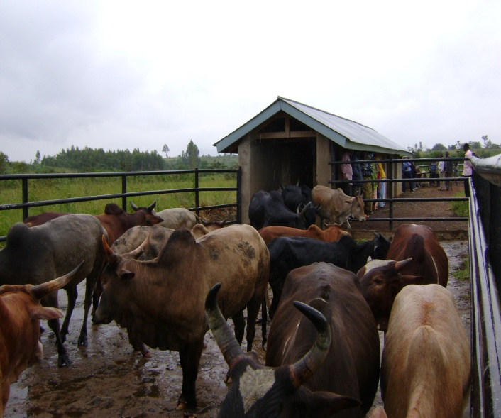 | 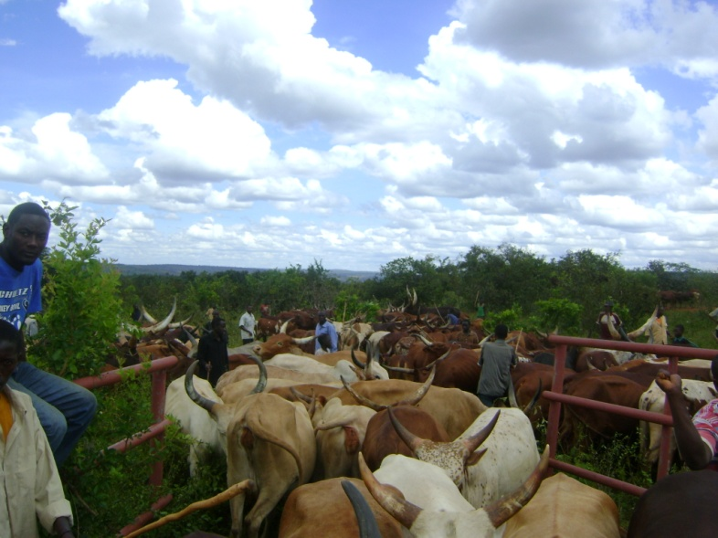

Figure 4. Cattle dipping at Nyamwaga village, Nyamwaga ward in Tarime district and cattle crush at Ichwankima village in Chato district. Cattle dipping has contributed significantly in reducing livestock mortality rates in DASIP supported villages with dips.

